The 9th Anniversary
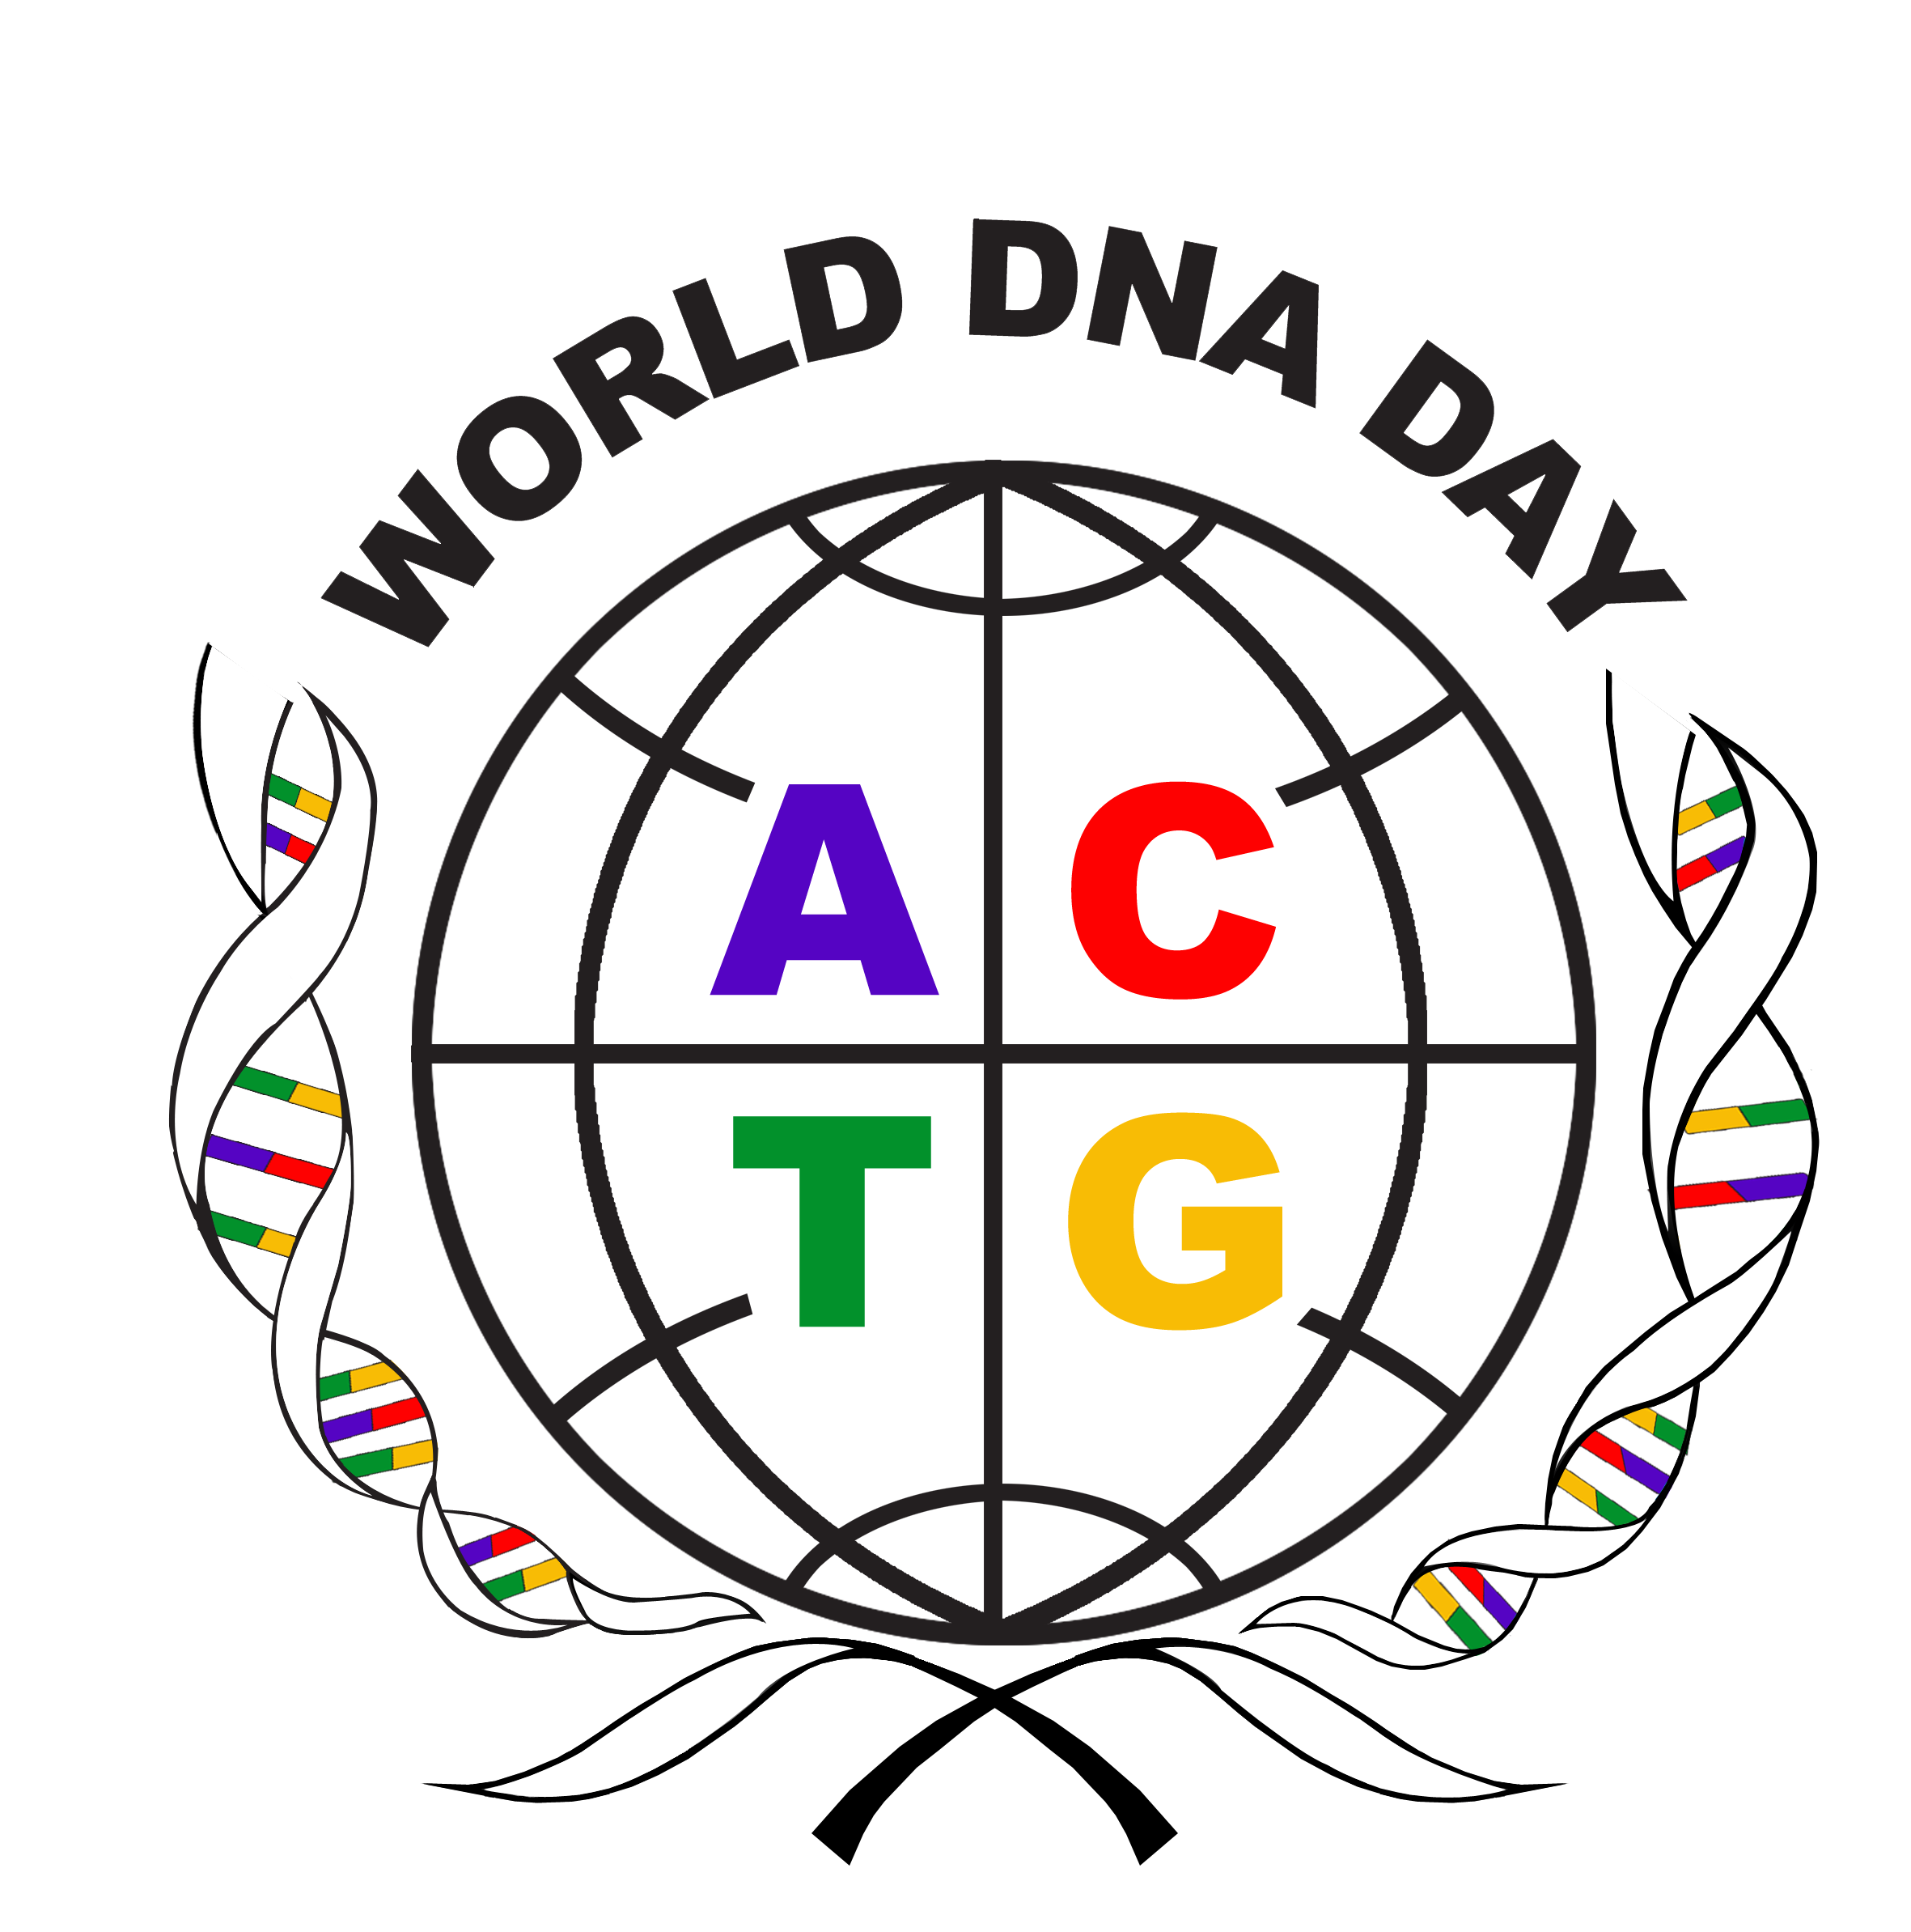
World DNA Day-2018
__________________________________________________________________________________________
Talent and Project Form
（If you have a project, please fill out this form. 项目持有单位/个人填写）

项目名称
Project Title
个人信息  Personal Information | 姓氏  Family Name |  | 名字  Given Name
个人信息  Personal Information | 职务  Professional Title |  | 国家  Country
地址  Address |  |  | 邮政编码  Post Code
电话  Phone |  |  | 邮箱  Email
项目所有权Project Ownership
项目阶段
Stage of the Project
合作方式  Cooperation Method | - Licensing  - Sale, the expecting amount: US$_____________  - Joint Venture  - Others: __________________
项目简介(不超过500字)
Project Brief(for identification purposes only: 500 words max):
个人简介(不超过500字)
Biography (for identification purposes only: 500 words max):

I authorize WCBG-2018 to use this form for technology transfer purpose.
Yes No
I guarantee the information provided is true and correct to the best of my knowledge and judgment and understand that I will responsible for any false and/or incorrect information submitted.
Yes No

